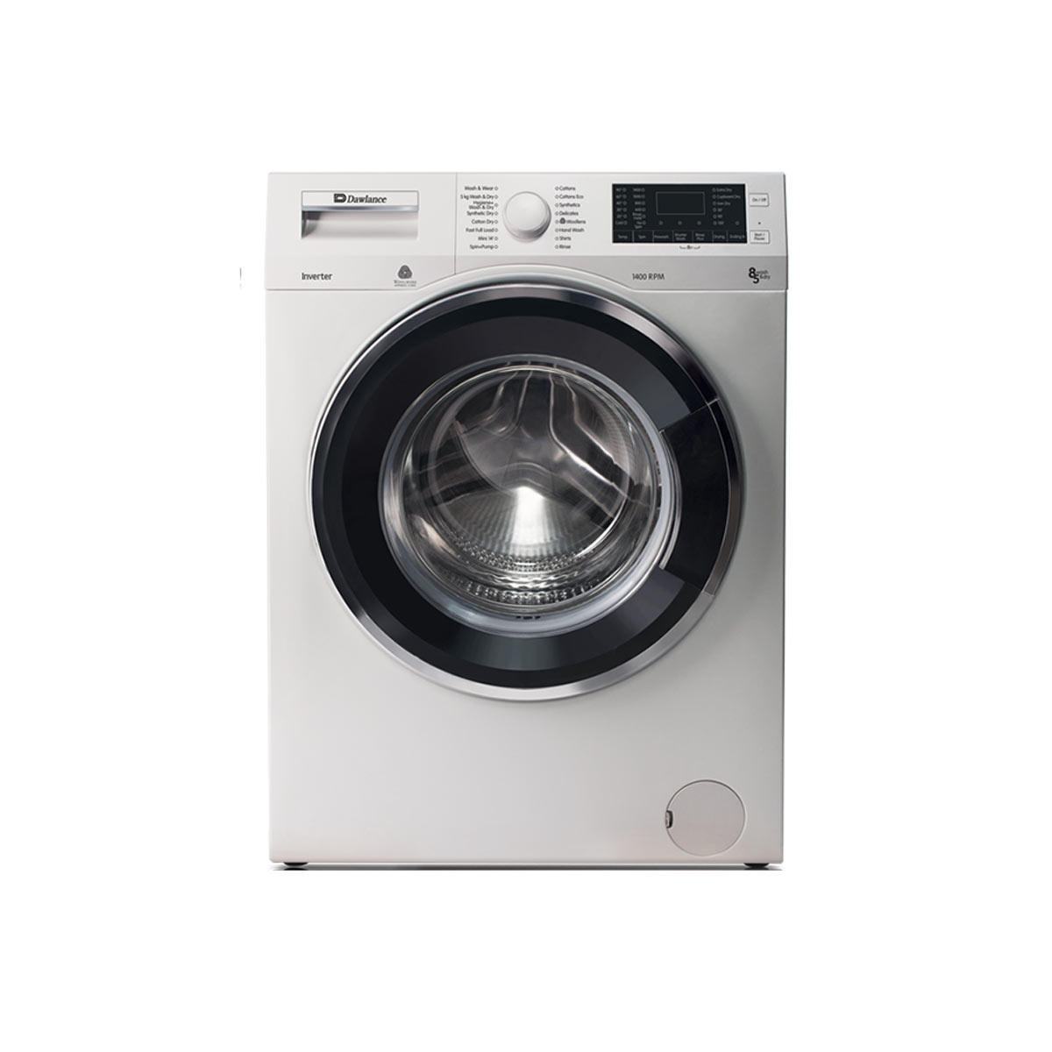

***Dawlance DWT 1775 PL e-care Top Load Washing Machine***

* **Color:**Silver/White
* **Available:**Out of Stock
* **Motor type:**Induction
* **Program:**10
* **Old Price:**~~Rs 235,000.00~~
* **New Price:**Rs 135,000.00